Managing Assignment

Many legislative offices have a point person who manages the legislator’s inbox while other staff members may take responsibility for responses to particular emails and the legislator or chief of staff has responsibility for approving outgoing emails.

LegCRM allows that common division of labor

* A user with *“All CRM functions”* capability (assigned by LIS) can view all emails in the inbox and assign particular emails to other users.
* All users can access can access the email inbox, but a user without *“All CRM functions”* functions authority can see only the **assigned** and **ready** tabs in the inbox and only see the emails that have been assigned to them.
* Only users with *“All CRM functions”* capability can send replies. Other users can only draft replies.

**Assigning Emails**

A user with *“All CRM functions”* capability can assign an email to another user when viewing the email.

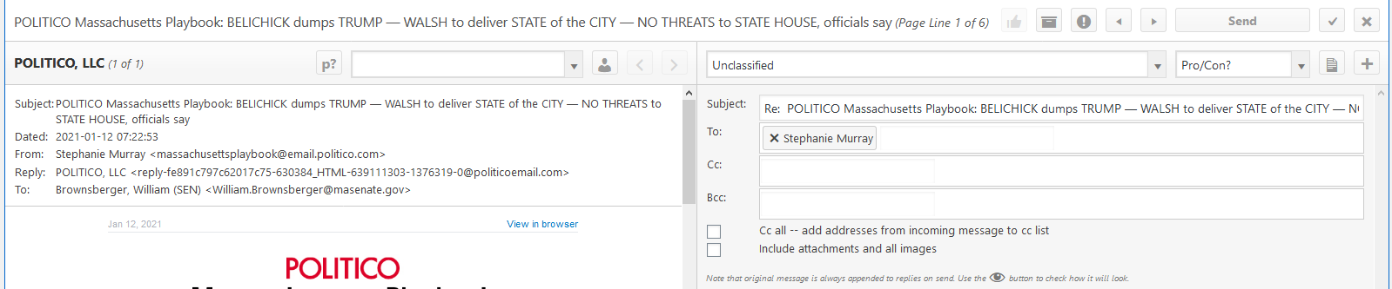

**Marking Emails as Ready**

The thumbs up/down toggle button moves emails back and forth between the Ready and Assigned Tabs. Any user can move their assigned emails between the two tabs. A user with *“All CRM functions”* capability can move emails for any user and can actually send drafted replies.

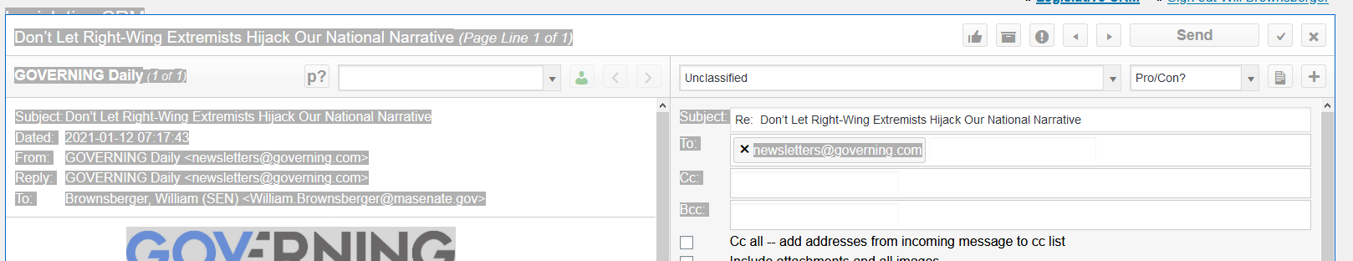

**Assigning Constituents**

In an office that includes interns, it may make sense to give the interns a special limited capability level: “*Only as assigned*”. At that level, the user will only be able to see their assigned emails (like other users who don’t have *“All CRM functions”* capability). And, in addition, they will be restricted to only their assigned cases. They will not be able to review constituent data for unassigned constituents.

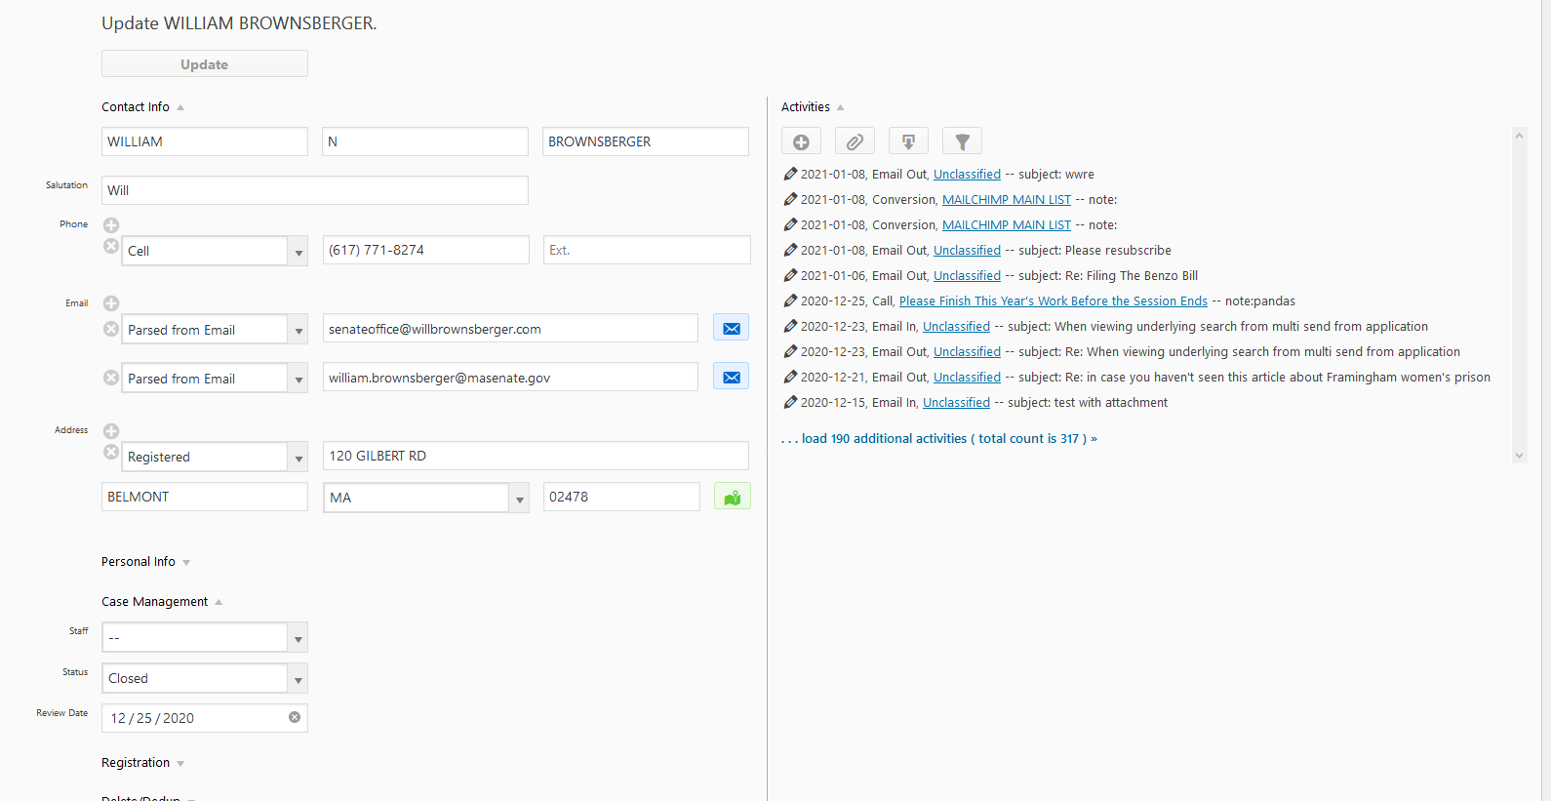

**Notes:**

1. When working on a draft reply, the system autosaves the draft with 5 seconds of any keystroke.
2. When a logged-in user with the *Access all email* capability views the inbox, the Assigned/Ready tabs will include all inbox emails with the exact same subject line as one assigned to any user or to the user selected from drop-down. This serves to move to the assigned tab those emails that will likely get trained replies once a response has been drafted to the assigned emails.
3. The assignment of a constituent to a user for case management will *not* affect whether emails from that user appear in the assigned tab. Email assignment is for particular emails and intended to support the delegation of drafting of a response to a particular email (or a group of emails with the same subject). If a staff members is engaging in ongoing correspondence with a constituent, they should user their own office email address.